6.Numerical Integration Trapezoidal Rule
Q. Write a program in python to demonstrate Trapezoidal RuleMethod.

Aim: To write a program in python to demonstrate Trapezoidal Rule Method. Program:
def f(x):

return 1 / (1 + x**2)

a = 0

b = 1

n = 2 # number of subintervals h = (b - a) / n
x = [a + i * h for i in range(n + 1)] f_values = [f(xi) for xi in x]
print("===============================================================")
print(" i x(i) f(x(i)) = 1/(1+x^2)")

print(" ")

for i in range(n + 1):

print(f" {i+1:<2d} {x[i]:<10.4f} {f_values[i]:<10.4f}")

print(" ")

I = (h / 2) * (f_values[0] + 2 * sum(f_values[1:-1]) + f_values[-1]) print(f"h = (b - a) / n = ({b} - {a}) / {n} = {h}")
print("\nUsing Trapezoidal Rule:") print("I = (h/2) * [f(x0) + 2f(x1) + f(x2)]")

print(f"I = ({h}/2) * [{f_values[0]:.4f} + 2{f_values[1]:.4f} + {f_values[2]:.4f}]") print(" ")
print(f"Approximate value of the integral I = {I:.4f}") print("===============================================================")
Result:
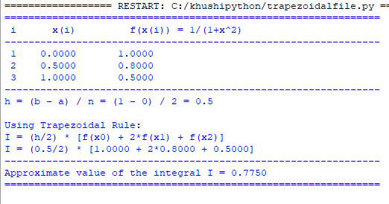
Conclusion: The above program has been executed successfully.

